Business Requirements Document (BRD)

Marriage Registration Module
Field | Value
Document ID | BRD-K3-MRG-001
Version | 2
Status | Draft / In review — BRD part (Executive summary through 7.v)
Module | Marriage Registration
Legal basis (primary) | The Hindu Marriage Act, 1955; The Special Marriage Act, 1954
State rules (primary) | Registration of Hindu Marriage (Karnataka) Rules, 1966; Special Marriage (Karnataka) Rules, 1961
Author (BA) | Nandha Kumar
Product Owner | Prashanth
Domain expert / SRO reviewer | Prabhakar Naik, Committee members
Target audience | Kaveri IT Cell, Department of Stamps and Registration, Government of Karnataka
Last updated | 03-09-2026

Document control
Version | Date | Author | Summary of change | Approver
1 | 27-08-2026 | Nandha Kumar | Initial BRD | Prashanth
2 | 03-09-2026 | Nandha Kumar | Review Committee suggestions:  - Updated Aadhaar OTP message to include a valid reason  - Updated process flow messages for notice filing  - Added age validation at the time of notice filing  - Added Form II for Hindu Marriage  - Added new sections on applicable Acts, Rules, and sections  - Split the document into separate BRD and FRS–NFR documents  - Added references in the pain-points section | Prashanth

Related documents:
ID | Title | Link
BRD-K3-MRG-HMA-001 | This document
FRS-NFRS-K3-MRG-001 | FRS and NFRs (Marriage) — 8–Appendix A | FRS_and_NFRS_Marriage_v1.23.docx

Contents

1. Executive summary 1
2. Scope 1
3. Legal and regulatory reference 2
i. Applicable Acts 2
ii. Relevant sections followed by the Department for Marriage Registration 2
iii. Relevant rules followed by the Department for Marriage Registration 4
iv. Relevant notifications issued by the Department for Marriage Registration 7
v. Hindu Marriage statutory forms mapping 8
vi. Special Marriage statutory forms mapping 12
vii. Sakala — Karnataka Guarantee of Services 16
4. Stakeholders and actors 17
5. Definitions and glossary 18
6. Current state 19
i. As-Is pain points 19
7. Future state (To-Be) 24
i. Hindu Marriage 24
ii. Special Marriage Notice Generation (Intended Marriage / Other Forms) 29
iii. Special Marriage Marriage Registration (Intended Marriage / Other Forms) 35
iv. Marriage — Null and Void Endorsement (Court Order) 39
v. What is new in Kaveri 3.0 40

Executive summary
This document presents a comprehensive assessment of the existing Hindu Marriage Registration process and Special Marriage (Intended Marriage / Other Forms) notice and registration processes, covering both online and offline service channels. It identifies key operational, procedural, and user experience challenges currently impacting applicants and Sub-Registrar offices.
Based on the analysis of the current state, the document proposes an enhanced future-state workflow aimed at improving accessibility, efficiency, transparency and service delivery. In addition, it defines the functional and non-functional requirements, outlines the data requirements required for effective implementation and management, and provides a reference to a detailed traceability matrix to ensure alignment between business objectives, requirements and solution deliverables.
The proposed approach is intended to streamline marriage registration services, reduce manual effort, enhance compliance, and establish a scalable foundation for future digital transformation initiatives.

Scope
- Hindu Marriage registration — Online and Offline channels.
- Special Marriage — Intended Marriage: notice generation (Online & Offline), objection period, solemnization and registration.
- Special Marriage — Other Forms: notice generation (Online & Offline), objection handling and registration.
- Citizen portal and SRO desk workflows: apply, pay fee, scrutiny, approve/reject, register, and issue certificate.
- Null and Void endorsement of a registered marriage on court order.
- Integrations: payment, Aadhaar/e-KYC, DigiLocker, SMS, e-Mail, Kutumba, Civil Registration System, Labor Department, and Sakala.
- Bilingual UI (English + Kannada); audit trail, role-based access, and MIS/reporting.

Legal and regulatory reference

Applicable Acts
The Department for Marriage Registration (through Sub-Registrars / Marriage Officers) administers the following Central Acts and Karnataka Rules:
Act | Description
The Hindu Marriage Act, 1955 | Registration of Hindu marriages (Sec. 8); conditions for marriage (Sec. 5); ceremonies (Sec. 7)
The Special Marriage Act, 1954 | Solemnization of special marriages (Chapter II); registration of marriages celebrated in other forms (Chapter III)
The Parsi Marriage and Divorce Act, 1936 | Parsi marriage registration
The Karnataka Guarantee of Services to Citizens Act, 2011 | Time-bound guarantee of citizen-related services; GSC acknowledgement; online status monitoring; appeals and compensatory cost (Secs. 3–13); amended by Karnataka Act 36 of 2012 and Karnataka Act 31 of 2014

Relevant sections followed by the Department for Marriage Registration

Hindu Marriage Act, 1955 (selected sections for registration)

Section | Topic | relevance | Refer section 7 for Implementation
Sec. 2 | Application of Act | Eligibility — Hindus (incl. Virashaiva, Lingayat, Brahmo/Prarthana/Arya Samaj), Buddhists, Jainas, Sikhs; | 7.i.b.A (service selection / Hindu marriage eligibility)
Sec. 3 | Definitions | Sapinda relationship and degrees of prohibited relationship — validation rules | 7.i.b.A (sapinda and prohibited-relationship capture)
Sec. 5 | Conditions for a Hindu marriage | Age (bridegroom ≥ 21, bride ≥ 18); no living spouse; consent; prohibited degrees / sapinda unless custom permits — Form IA declarations | 7.i.b.A (prerequisite, declarations and Form IA)
Sec. 7 | Ceremonies for a Hindu marriage | Customary rites and ceremonies; Saptapadi — solemnization evidence | 7.i.b.A (marriage details / ceremony evidence)
Sec. 8 | Registration of Hindu marriages | State rules power; register open for inspection; certified extracts; validity of marriage not affected by omission to register | 7.i.b.B, 7.i.b.C, 7.i.b.D (registration process and status)
Sec. 11–12 | Void / voidable marriages | Court nullity endorsement — SRO flags registered marriage Null and Void on receipt of court order (Sec. 11 void; Sec. 12 voidable / annulled) | 7.iv (court-order null/void endorsement)
Sec. 17 | Punishment of bigamy | Messaging linked to Sec. 5(i) declaration | 7.i.b.A (no living spouse declaration messaging)
Sec. 18 | Punishment for other Sec. 5 breaches | Citizen / SRO awareness — not automated prosecution | — (citizen / SRO awareness only)

Special Marriage Act, 1954 (selected sections)

Section | Topic | BRD relevance | Implemented in (7)
Sec. 4 | Conditions relating to solemnization | Eligibility / prerequisite checks before notice | 7.ii.b.A, 7.iii.b.A (solemnization eligibility checks)
Sec. 5 | Notice of intended marriage (Second Schedule) | Generate and capture notice; jurisdiction — ≥ 30 days residence of at least one party | 7.ii.b.A–7.ii.b.D (notice generation and capture)
Sec. 6 | Marriage Notice Book and publication | Enter notice; publish on portal and/or notice board; transmit if party resides elsewhere | 7.ii.b.B, 7.ii.b.C (Marriage Notice Book and publication)
Sec. 7 | Objection to marriage (30 days) | 30-day countdown from publication; accept and record objections | 7.ii.b.D, 7.iii.b.C (30-day objection window)
Sec. 8–9 | Procedure / enquiry on objection | SR enquiry; summon parties; uphold or reject objection | 7.ii.b.D, 7.iii.b.C (objection enquiry workflow)
Sec. 11 | Declaration by parties and witnesses (Third Schedule) | Declarations before solemnization; three witnesses | 7.iii.b.A–7.iii.b.B (Third Schedule declarations)
Sec. 12–13 | Solemnization and certificate of marriage (Fourth Schedule) | Office solemnization; certificate issuance | 7.iii.b.B (solemnization and Fourth Schedule certificate)
Sec. 14 | New notice if not solemnized within three months | Block registration outside validity; require fresh notice | 7.iii.b.C (notice validity / fresh-notice gate)
Sec. 15 | Registration of marriages celebrated in other forms | Other Forms eligibility — ceremony performed; parties living together; ages; residence ≥ 30 days | 7.ii.b.A, 7.iii.b.A (Other Forms eligibility)
Sec. 16 | Procedure for registration — Other Forms (Fifth Schedule) | Public notice; 30-day objections; certificate with three witnesses | 7.ii.b.x, 7.iii.b.x (Other Forms notice and registration)
Sec. 47–48 | Marriage Certificate Book; transmission to Registrar-General | Inspection; certified extracts; quarterly transmission | 7.iii.b.B, 7.iii.b.C (register entry; extracts — partial back-office)

Relevant rules followed by the Department for Marriage Registration
Karnataka subordinate legislation made under the Hindu Marriage Act, 1955 (Sec. 8) and the Special Marriage Act, 1954 (Sec. 50).

Registration of Hindu Marriage (Karnataka) Rules, 1966
Rule | Requirement | Refer section 7 for Implementation
Rule 2 | Definitions — Act, form, Marriage, Memorandum, Priest, Register, Registrar, Registrar-General, witness | 7.i.b.A (glossary-driven eligibility validation)
Rule 3(1) + S.O. 4896 | Appointment of Registrars; all Sub-Registrars under Registration Act 1908 appointed Registrars for their jurisdictions (HD 6 CIM 61, 4 Jul 1966) | 7.i.b.B step 8, 7.i.b.C (SRO office / jurisdiction routing)
Rule 4(1) | Parties prepare and sign Form I in duplicate; deliver in person, registered post or electronically; jurisdiction = marriage place or ordinary residence of bridegroom/bride | 7.i.b.B, 7.i.b.C (Online / Offline filing and office selection)
Rule 4(2) | Memorandum delivered with application in Form IA | 7.i.b.A–7.i.b.C (Form IA linked to memorandum)
Rule 4(3) | Memorandum and duplicate signed by three witnesses | 7.i.b.A, 7.i.b.C (three witnesses; eSign / physical signature)
Rule 4(4) | Endorsement in Form II; paste in paste-book register or stored electronically | 7.i.b.B, 7.i.b.C (Form II endorsement / register entry)
Rule 4(5) | On completion of registration, immediately issue Form II-A certificate | 7.i.b.B, 7.i.b.C (Form II-A certificate issuance)
Rule 5 | Monthly duplicate memoranda to Registrar-General with Form III certificate | — (monthly Form III batch — 8.6 back-office)
Rule 6 | Indices Forms IV and V at every Registrar | — (Forms IV & V indexes — 8.6 MIS / search)
Rule 6A | Power to require duplicate / Form IA / remedy defects; forward if outside jurisdiction; scrutinise and refuse with brief written order | 7.i.b.B, 7.i.b.C (defect remedy, forward, written refusal)
Rule 8 + Schedule | Certified extracts on application + fee; search fee provisions | 7.i.b.B, 7.i.b.C (payment and certified-extract fees)
Rule 9 | Receipt in Form VI for every fee; credit to State Government | 7.i.b.B, 7.i.b.C (Form VI payment receipt)
Rule 10 | Custody and preservation of registers and records | — (records retention — NFR / archival policy)

Special Marriage (Karnataka) Rules, 1961

Rule | Requirement | Implemented in (7)
Rule 3 | Marriage Officer shall display name, designation and working hours in English and Kannada | 7.ii.b.A (Marriage Officer office master / display)
Rule 4 | Notice in Second Schedule form; in person or registered post; fee on delivery; serial number and Marriage Notice Book entry; exhibition of true copy | 7.ii.b.A–7.ii.b.D (Second Schedule notice generation)
Rule 6 | Objection enquiry — recording, summons (Forms I & II), 30-day enquiry window, decision in writing | 7.ii.b.D, 7.iii.b.C (objection enquiry and decision)
Rule 7 | Application for registration of marriage in other forms (Form III); public notice exhibition; 30-day objection period | 7.ii.b.x, 7.iii.b.x (Other Forms Form III notice path)
Rule 8 | Solemnization outside office on application + additional fee | 7.iii.b.B (optional out-of-office solemnization fee)
Rule 9 | Marriage Certificate Book — bound volume, consecutive numbering, index | 7.iii.b.B (Marriage Certificate Book / numbering)
Rule 10 | Fee schedule — notice fee, registration fee, objection fee, certified copy, search, process fee, out-of-office solemnization | 7.ii.b.x, 7.iii.b.x (first and second payment per fee schedule)
Rule 11 | Quarterly certified copies of entries to Registrar-General (Form IV) | — (quarterly Form IV export — 8.6 back-office)

Relevant notifications issued by the Department for Marriage Registration
Gazette notifications, Government Orders and amendments cited in the Karnataka Rules or issued under the Acts.
Instrument | Date / No. | Effect | Refer section 7 for Implementation
S.O. 4896 / HD 6 CIM 61 | 4 Jul 1966 | Appoints all Sub-Registrars as Registrars of Hindu Marriages for their jurisdictions | 7.i.b.B, 7.i.b.C (Sub-Registrar as Registrar routing)
Registration of Hindu Marriages (Karnataka) (Amendment) Rules, 1999 | w.e.f. 8 Jun 2000 | Priest / witness definitions; Form IA; three-witness signing; Form II-A immediate certificate; scrutiny / refusal order; Schedule fees | 7.i.b.A–7.i.b.C (Forms IA & II-A; SR scrutiny and refusal)
G.S.R. 314 / G.S.R. 394 / HD 5 PIM 69 | 1968–1969 | Substitutions / additions to Rule 4 jurisdiction and memorandum clauses | 7.i.b.B, 7.i.b.C (Rule 4(1) jurisdiction / memorandum)
RD/48/MNMU/2023 — Registration of Hindu Marriage (Karnataka) (Amendment) Rules, 2024 | Gazette 06-Feb-2024, Part-IVA No. 60; under HMA Sec. 8(1) | Amends Rule 4: insert 'or electronically' (r.4(1)); 'or stored electronically' (r.4(4)); 'or stored in electronic media' (r.4(5)) | 7.i.a, 7.i.b.B (Online channel; electronic register and certificate)
Special Marriage (Karnataka) Rules, 1961 | Notification No. HD 13MCIM 59(1), 2 May 1961 | Original notification making the Karnataka Special Marriage Rules | 7.ii, 7.iii (Special Marriage notice and registration)
koE/65/mnmu/2021 dated 05/04/2021  circular | 05/04/2021 | Age proof documents – Birth certificate, School Certificate, if these are not available then medical certificate from the doctor.  AADHAR cannot be considered for age proof | 7.b.x Hindu Marriage Online and Offline  7.ii.b, 7.iii.b Special Marriage
MME 109 MABHAB 2017  circular | 01/08/2018 | Address Proof Documents: Aadhaar Card, (Electricity/Telephone/Water) Bill,  Voter ID Card, Gas connection certificate, Rental Agreement, Income Tax Assesment, Employer certificate, Passport, Bank Passbook (national and regional rural banks) | 7.b.x Hindu Marriage Online and Offline  7.ii.b, 7.iii.b Special Marriage
Karnataka Guarantee of Services to Citizens Rules, 2012 | Gazette 29-Feb-2012 (published 14-Feb-2012 draft) | Subordinate rules under Sec. 19 of the Sakala Act — acknowledgement, appeals, compensatory cost and monitoring procedures | 3.vii; 8.7 (GSC acknowledgement and lifecycle — no separate 7 process)

Hindu Marriage statutory forms mapping
Forms under the Registration of Hindu Marriage (Karnataka) Rules, 1966. Source: Acts_Rules/Marriage/Form1.pdf and hindu marriage forms.pdf.
Form | Rule ref | Purpose | Generated by
Form I | Rule 4 | Memorandum of marriage (duplicate) | System from captured data + joint photo
Form IA | Rule 4(2) | Application for filing of marriage memorandum | System from captured data + declarations
Form II | Rule 4(4) | Endorsement on reverse of memorandum and duplicate: date received; serial no.; page; volume of Register under HMA 1955; Registrar signature | System on SR digital signature (both channels); blank template in Offline printout pack before endorsement
Form II-A | Rule 4(5) | Certificate of registration of marriage under HMA 1955 | System on approval / SR DSC
Form III | Rule 5(1) | Certificate affixed to monthly duplicate memoranda bundle | Back-office batch export
Form IV / V | Rules 5(2), 6 | Indices of register entries | Reporting / search
Form VI | Rule 9 | Fee receipt | Payment integration

Form 1
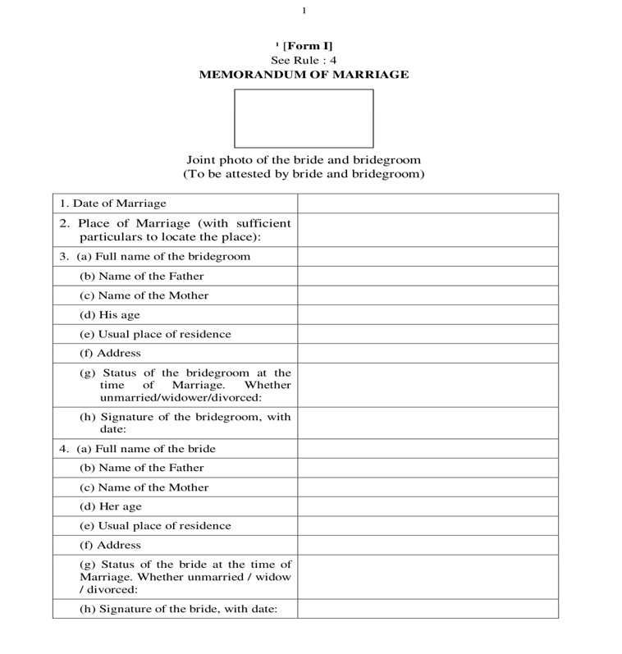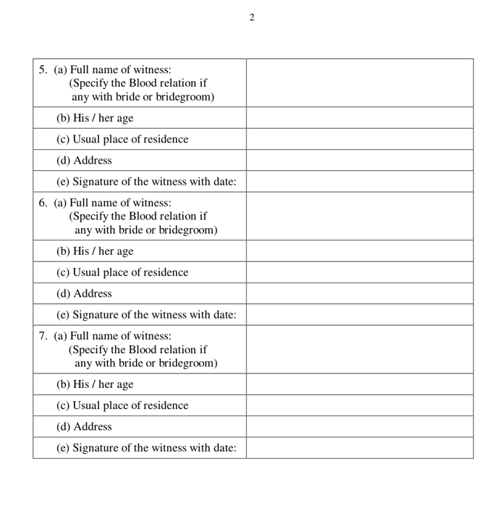
Form I — Memorandum of marriage (page 1 & 2).

Form IA

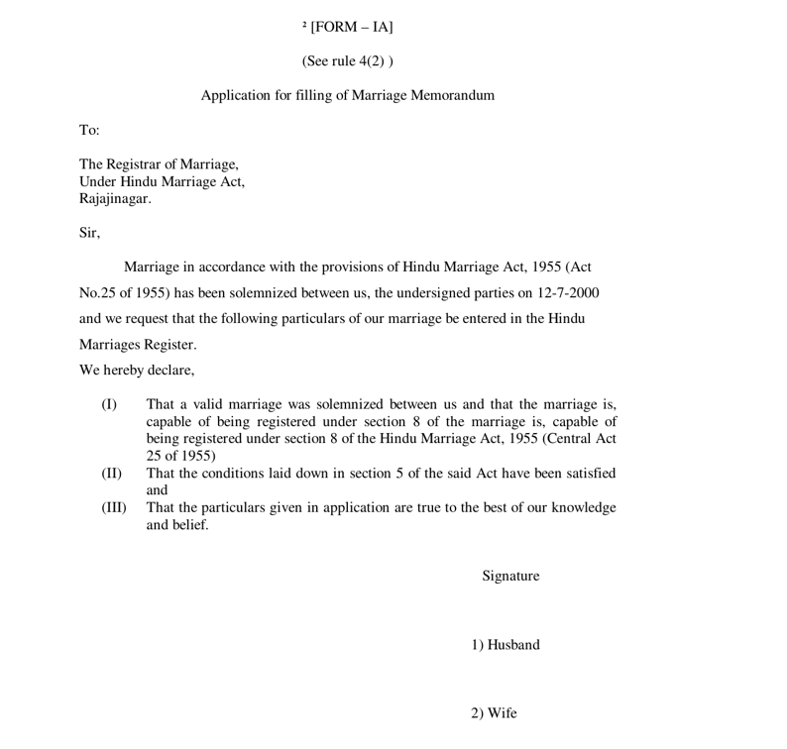
Form IA — Application for filing of marriage memorandum (Rule 4(2))

Form II

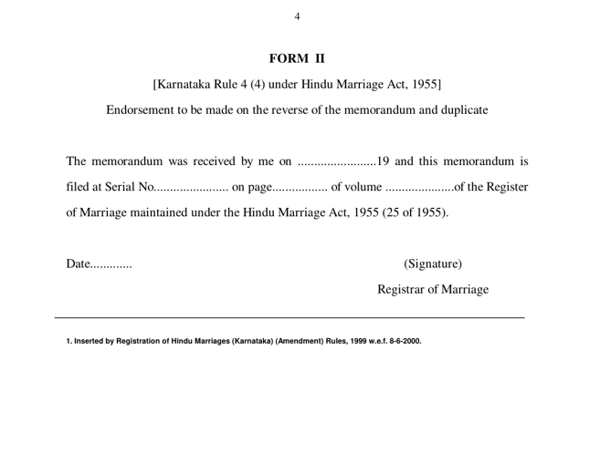
Form II — Endorsement on reverse of memorandum and duplicate (Rule 4(4)).

Form II - A

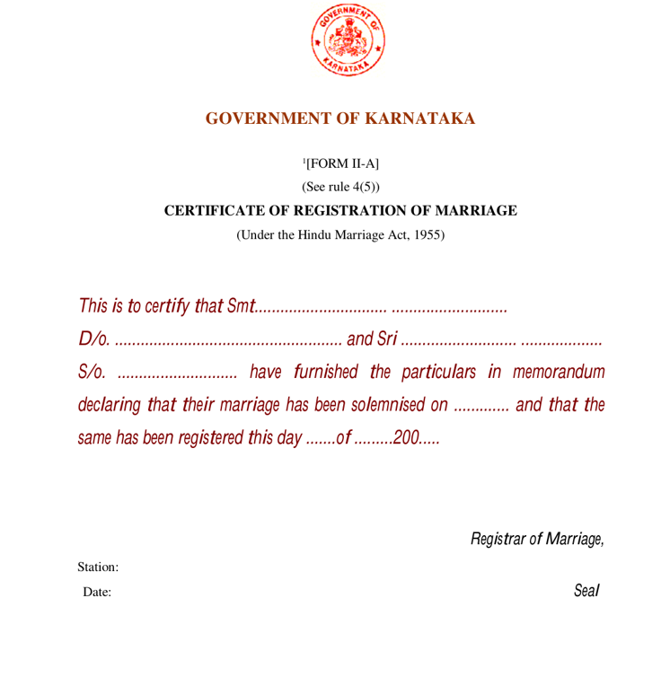
Form II-A — Certificate of registration of marriage (Rule 4(5)).

Statutory penalty highlights — Sec. 17 & Sec. 18 (displayed in red at submission)
The following extracts from the Hindu Marriage Act, 1955 shall be shown to the parties in red highlight panels when Form I / Form IA is submitted (Online and Offline) — see FR-HMA-091. Wording below is the statutory reference text for legal review; UI may abbreviate for readability without altering legal meaning.

- Sec. 17 — Punishment of bigamy: Any marriage between two Hindus solemnized after the commencement of this Act is void if at the date of such marriage either party had a husband or wife living; and the provisions of sections 494 and 495 of the Indian Penal Code (45 of 1860), shall apply accordingly.
- Sec. 18 — Punishment for contravention of certain other conditions for a Hindu marriage: Contravention of section 5(iii) (minimum age — bridegroom 21 years, bride 18 years): imprisonment which may extend to two years, or fine which may extend to one lakh rupees, or both. Contravention of section 5(iv) (degrees of prohibited relationship) or section 5(v) (sapinda relationship): simple imprisonment which may extend to one month, or fine which may extend to one thousand rupees, or both.

Special Marriage statutory forms mapping
Schedules under the Special Marriage Act, 1954 and forms under the Special Marriage (Karnataka) Rules, 1961
Form / Schedule | Act ref | Purpose | Generated by
Notice of Intended Marriage (Second Schedule) | Sec. 5 / Sec. 6 | Statutory notice for Intended Marriage | System + SR generation; portal / notice-board publication
Declarations (Third Schedule) | Sec. 11 | Declarations by parties and witnesses before solemnization | System / office capture
Certificate of Marriage (Fourth Schedule) | Sec. 13 | Certificate after solemnization under Chapter II | System on SR DSC
Certificate of Marriage (Fifth Schedule) | Sec. 16 | Certificate for marriages registered under Chapter III (Other Forms) | System on SR DSC
Form I / II (Karnataka Rules) | Rule 6(4) | Notice / summons for objection enquiry | System on objection workflow
Form III (Karnataka Rules) | Rule 7(1) | Application for registration of marriage celebrated in other forms | System on Other Forms path
Form IV (Karnataka Rules) | Rule 11 | Certified copy of entries transmitted to Registrar-General | Back-office quarterly export

Form - Notice of Intended Marriage
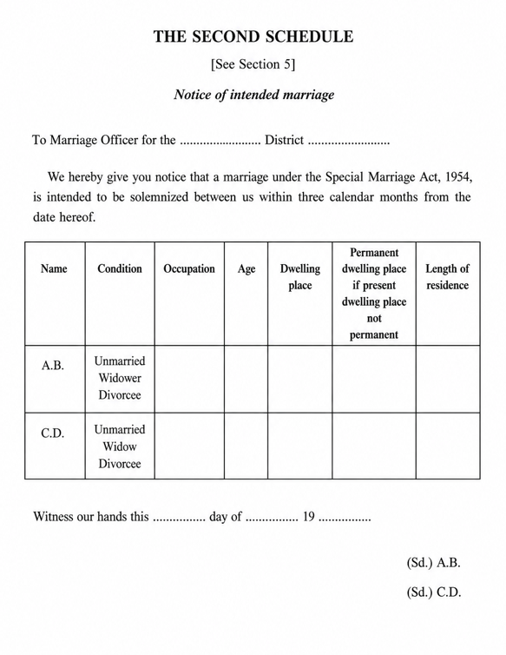
Second Schedule — Notice of intended marriage (Sec. 5 / Sec. 6).

Form - Declaration

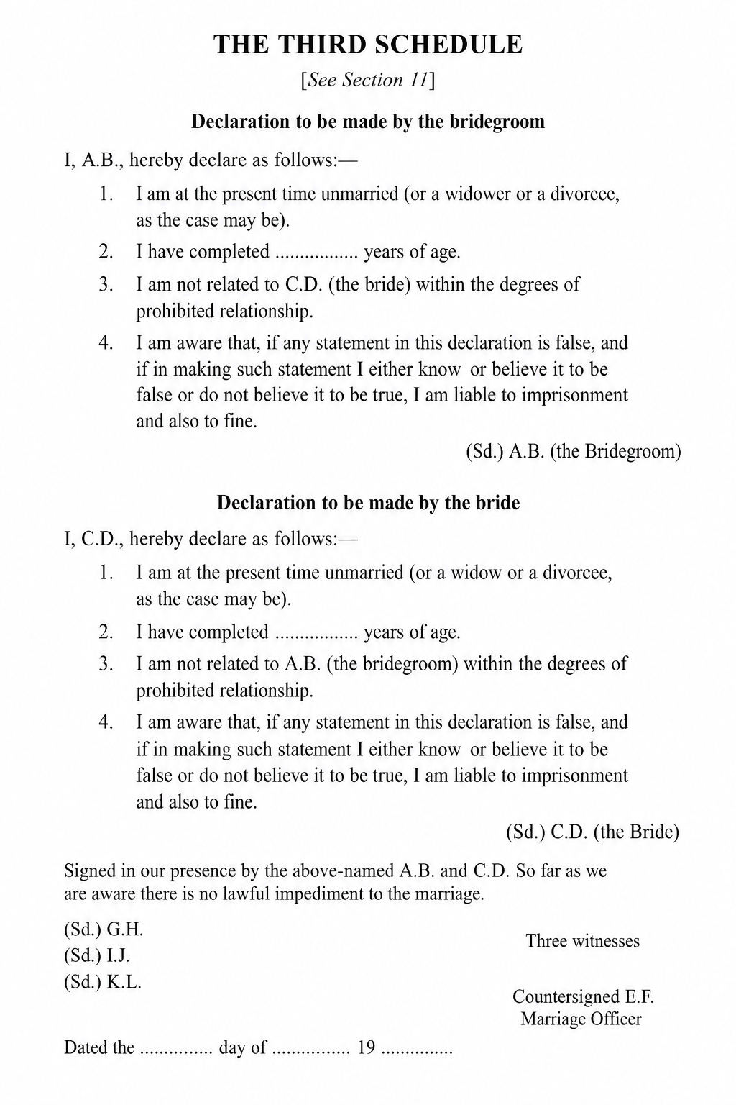
Third Schedule — Declarations by parties and witnesses (Sec. 11).

Form – Certificate – Special Marriage

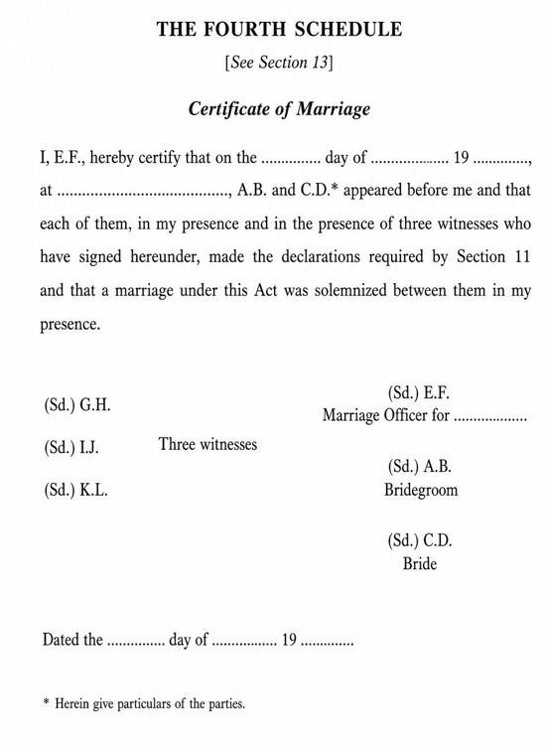
Fourth Schedule — Certificate of marriage after solemnization (Sec. 13).

Form – Certificate – Special Marriage (Other Forms)

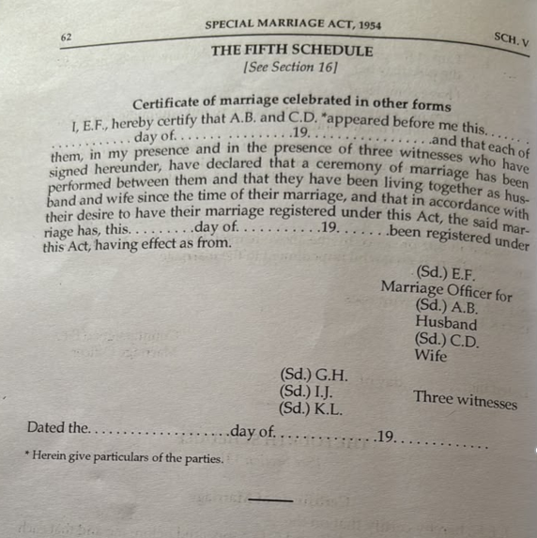
Fifth Schedule — Certificate of marriage celebrated in other forms (Sec. 16). Source: Acts_Rules/Marriage/SpecialOtherFormsCertificate.jpeg

Sakala — Karnataka Guarantee of Services
Source: 3.i (Karnataka Act 1 of 2012); 3.ii.3 (selected sections); 3.iii.3 (Rules, 2012); Sakala Mission portal — https://sakala.kar.nic.in/. Marriage registration services offered through the Department of Stamps and Registration are notified Sakala services. Every eligible application shall receive a Guarantee of Services to Citizen (GSC) number so citizens can track status, receive time-bound service and file appeals (Appeal-I / Appeal-II) when service is delayed or rejected.
Notified marriage-related Sakala services (department baseline — confirm codes with Sakala Mission during integration design):
- Hindu Marriage registration (online filing) — GSC issued on successful fee payment; statutory service timeline commences from payment date (typically 1 working day for certificate delivery after payment, per department practice).
- Special Marriage — Intended Marriage notice and registration.
- Special Marriage — Other Forms notice and registration.
Kaveri 3.0 shall integrate with the Sakala platform per NIC / Sakala Mission approved web methods for GSC registration, status updates (acceptance, in-process, delivered, rejected), party-detail upload and orphan-settle retry — see 8.7 and 11. (FRS and NFR document)

Stakeholders and actors
Actor | Description | Primary goals | Channel involvement
Bride / Bridegroom (citizens/applicant) | Parties to marriage | Sign declarations, provide documents | Online: eSign; Offline: physical signature on printed Form I / IA / II / II-A
Witness (×3) | Present at solemnization | Identity, address, signature on memorandum | Online: eSign / e-KYC / Face Authentication [TBD]; Offline: physical signature
Marriage Registrar / Sub-Registrar (SR) | Statutory registrar | Verification, register, digital signature, refuse with order | Online: single verification; Offline: two verification stages
Data Entry Operator (DEO) | SRO-office operator handling physically signed forms | Check signatures on printed Form I / IA / II / II-A and upload to portal | Offline only
Treasury / payment gateway | Fee collection | e-Payment, Reconciliation | Both (payment triggered after first SR approval)
eSign / DSC service provider | Digital signing | Citizen eSign (online), SR digital signature (both) | Both
Domain Expert | Validation | Sign-off on rules and forms | Review workshops
Sakala (Karnataka Guarantee of Services) | Statutory time-bound service delivery platform (Sakala Mission / NIC) | Issue GSC on acceptance/payment; track statutory timelines; sync lifecycle (in-process / delivered / rejected); citizen tracking and appeals | Both (GSC and status sync for Online and Offline Hindu / Special Marriage services)

Definitions and glossary
Term | Definition
Memorandum | Form I particulars of marriage
Registrar | Registrar of Hindu Marriages (Sub-Registrar)
Register | Paste-book Hindu Marriage Register (Bride/Groom Registers)
Solemnization | Performance of customary rites (Section 7)
Hindu Marriage Online | Channel where citizen selects Online first, completes combined prerequisite+declaration, captures details with e-KYC / Face Authentication/Face Authentication on Bride, selects office, submits Form 1 with eSign; no physical form submission
Hindu Marriage Offline | Channel where citizen selects Offline first, completes combined prerequisite+declaration, captures details, undergoes SR Stage 1, pays and books appointment, prints Form I, SR allocates to DEO for signature check and upload, then SR Stage 2 and DSC
eSign | Electronic signature applied by citizen on Form I (Memorandum) and Form IA (Application) in the Online channel
SR digital signature (DSC) | Digital signature applied by Sub-Registrar before certificate issuance (both channels)
SR Verification | Sub-Registrar scrutiny decision (Approve / Reject). Offline has two occurrences: pre-payment data verification and post-upload signed-form verification
Data Entry Operator (DEO) | Checks signatures on the printed forms and uploads them to the portal (Offline only)
Appointment | Scheduled SRO visit slot booked by the citizen together with payment in the Offline channel
Special Marriage (Intended Marriage) Notice | Chapter II notice of intended marriage under SMA 1954 Sec. 5–7; Online or Offline notice generation before solemnization
Special Marriage (Intended Marriage) Registration | Post-notice solemnization & certificate issuance when timeline ≥30 and ≤90 days and no valid objection
Special Marriage Other Forms | Chapter III registration of marriages celebrated in other forms (SMA Sec. 15–16), with notice publication and objection period
Marriage Notice Book | Statutory book in which notices under Sec. 5 / Sec. 16 are entered and open to inspection (Sec. 6)
30-day countdown | Statutory objection / waiting period from notice publication (Sec. 7 / Sec. 16)
First Payment / Second Payment | Fee collected at notice stage (first) and at registration/solemnization stage (second) per Karnataka Special Marriage fee schedule
GSC (Guarantee of Services to Citizen) | Unique Sakala acknowledgement number issued for notified services; enables citizens to track application status and file appeals at https://sakala.kar.nic.in/
Sakala | Karnataka Guarantee of Services to Citizens programme (Act, 2011); mandates time-bound delivery and accountability for notified government services

Current state

As-Is pain points
Pain points evidenced from Kaveri 2.0 workshops, ServiceDesk tickets and department discussions. The Addressed in column maps each item to the To-Be process in this BRD (7) and to functional / non-functional requirements, fallbacks and risks in the companion FRS and NFRs document (FRS_and_NFRS_Marriage_v1.22.docx — 8–18).
Sr.No | Pain Point | Description | Source | Addressed in (BRD / FRS·NFR)
1 | Not mobile-friendly | The application is not usable on mobile browsers, limiting citizen access on phones and tablets. | Discussion | BRD 7.v (UI/UX); 7.i.a / 7.ii.a Online channels; FRS/NFRS: 10 UI; 15.4 NFR-MRG-VAPT-002 (mobile-responsive interfaces)
2 | Incorrect address on certificate | Sub-district is incorrectly included in the address shown on the marriage certificate. | Discussion | BRD 7.i.b.A common intake (party address); 7.i.b.B / 7.i.b.C certificate issuance; FRS/NFRS: 8.1.3–8.1.5; FR-HMA-008, FR-HMA-010/011; 8.1.16 FR-HMA-030/080/081
3 | Complex area/village selection | Selecting area or village is cumbersome and difficult for applicants to complete accurately. | Discussion | BRD 7.i.b.A common intake (jurisdiction / area selection); FRS/NFRS: 8.1.2; FR-HMA-005, FR-HMA-008; 11 Integrations (MDM / address master)
4 | Restrictive document upload rules | Uploaded image file size is too small, and mandatory pixel/dimension checks block valid uploads. | Discussion | BRD 7.i.b.A common intake (supporting documents); FRS/NFRS: 8.1.9; FR-HMA-065, FR-HMA-018/019
5 | Missing Save action for Witness 3 | The 'Save Witness 3' action is missing from the workflow. | Discussion | BRD 7.i.b.A common intake (witnesses); FRS/NFRS: 8.1.6; FR-HMA-012–014; BR-HMA-001
6 | Edit does not return to correct step | Using Edit from an in-progress marriage application does not open the latest or relevant step (e.g., Marriage Details screen). | Discussion | BRD 7.i.b.D Application Status Model; FRS/NFRS: 8.1.15; FR-HMA-073/074; BR-HMA-014, BR-HMA-017
7 | Documents not visible during scrutiny | Supporting documents uploaded with the application are not reliably visible to marriage registrar during application scrutiny. | Discussion | BRD 7.i.b.B Online / 7.i.b.C Offline (SRO scrutiny); FRS/NFRS: 8.1.11; FR-HMA-026
8 | No edit flexibility before payment | Applicants cannot freely go back to earlier steps and edit data. | Discussion | BRD 7.i.b process (edit until payment / eSign gate); FRS/NFRS: 8.1.13; FR-HMA-052; BR-HMA-010
9 | No processing priority order | Applications are not handled in first-in, first-out (FIFO) order, affecting fairness and turnaround time. | Discussion | BRD 7.i.b.D Application Status Model (officer queue); FRS/NFRS: 8.1.11; FR-HMA-077; 8.6 FR-HMA-042 (cycle-time MIS)
10 | Password-protected uploads not handled | The system accepts or fails unclearly on password-protected documents instead of blocking them with a clear message. | Discussion | BRD 7.i.b.A common intake (document upload validation); FRS/NFRS: 17 FB-MRG-003; 8.1.9 FR-HMA-065
11 | Limited notification channels | Notifications are not sent through both SMS and email as expected by the citizens and officers. | Discussion | BRD 7.i.b / 7.ii.b process; 7.v (payments and notifications); FRS/NFRS: 8.5; FR-HMA-036–038; FR-SMA-054; FB-MRG-004
12 | No operational dashboard visibility | There is no dashboard showing daily registration count, pending applications, or processed applications. | Discussion | BRD 7.v What is new in Kaveri 3.0; FRS/NFRS: 8.6; FR-HMA-041–045; FR-SMA-055–058
13 | Wrong DEO allocation and no reassignment | Applications are frequently allocated to the wrong DEO by mistake. Officers cannot return, reassign, clear, or remove applications from DEO login without ServiceDesk intervention (~66 tickets; 8 in last 3 months — still active). | Service Desk | BRD 7.i.b.C Offline (SR allocates / reassigns DEO); FRS/NFRS: 8.1.14; FR-HMA-069, FR-HMA-088; 16 RS-MRG-003
14 | Notice workflow state errors | After notice period completion, the system still shows Generate Notice or Print Notice instead of advancing. Notice steps reappear after second payment. | Service Desk | BRD 7.ii.b.D / 7.iii.b.C Application Status Model; FRS/NFRS: 8.2.8; FR-SMA-019–032, FR-SMA-024–026
15 | Blank challan / verify-challan loop | Citizen payment fails because the portal shows Verify Challan with a blank challan, forcing repeated payment attempts and helpdesk tickets (~38 tickets). | Service Desk | BRD 7.i.b.B / 7.ii.b.B Online payment; 7.v (payments); FRS/NFRS: 8.1.10; 17 FB-MRG-001; NFR-MRG-PAY-001; FR-HMA-025, FR-SMA-052
16 | Stuck on summary page — cannot go to next step | Users cannot proceed past the summary/review page to the next workflow step, leaving applications blocked mid-process (~41 tickets). | Service Desk | BRD 7.i.b / 7.ii.b.B process (summary → next step); FRS/NFRS: 8.1.13; FR-HMA-051, FR-HMA-052; FR-SMA-012; FR-HMA-038
17 | DOB and party details not reflecting | Date of birth and related bride/bridegroom details entered in the application do not reflect on subsequent screens or the certificate (~21 tickets). | Service Desk | BRD 7.i.b.A / 7.ii.b.A party particulars; FRS/NFRS: 8.1.4–8.1.5; 8.2.3; FR-HMA-058, FR-HMA-089; FR-SMA-009/062/063/066
18 | Place of marriage missing in summary/report | Place of Marriage captured during data entry does not appear in the review summary page or summary report (~12 tickets; also listed in curated issues list). | Service Desk | BRD 7.i.b.A / 7.ii.b.A marriage details (place of marriage); FRS/NFRS: 8.1.3; 8.2.2; FR-HMA-017; FR-HMA-051
19 | Cross-reference to registered marriage missing | There is no usable provision to add cross-references to a registered marriage. Multiple recent tickets (May–Jun 2026) request this repeatedly. | Service Desk | BRD 7.v What is new in Kaveri 3.0 (post-registration search); FRS/NFRS: 8.4; FR-HMA-034; 12.1 Core entities
20 | Signatures missing on digitally signed certificate | After digital signing, bride, bridegroom, and witness signatures do not appear on the generated certificate | Service Desk | BRD 7.i.b.B Online DSC / certificate; 7.iii.b.B solemnization & certificate; FRS/NFRS: 8.1.16; 8.3.iii; FR-HMA-054/080; FR-SMA-040/048; BR-HMA-001, BR-SMA-011
21 | Notice number and notice date not displaying | Notice number and notice date do not show on the relevant screens after notice generation, affecting verification and further processing (repeated in last 3 months). | Service Desk | BRD 7.ii.b notice generation / publication; 7.ii.b.D status model; FRS/NFRS: 8.2.5–8.2.7; FR-SMA-014/016/021; FR-SMA-055

Future state (To-Be)
The Marriage Registration To-Be model is organized by service. Each service documents its Channel models, Process Diagram (Common intake steps, Online and/or Offline (In Person) flows) and Application Status Model. The module covers Hindu Marriage (Online / Offline) and Special Marriage notice generation (Intended Marriage and Other Forms share one workflow) followed by marriage registration (shared workflow with path-specific timeline and certificate-schedule branches). Notice channels are initiated through the citizen portal; registration is completed In Person at the Sub-Registrar office.

Hindu Marriage

Channel models
Hindu Marriage supports Online and Offline (In Person) channels. Channel is selected before prerequisites and drives subsequent screens, payment timing and office tasks.
Service Type | Online Activities | Office Activities | Mode
Hindu Marriage Online | Registration, e-KYC / Face Authentication (Bride), eSign, Payment (post-approval), Tracking | Verification, DSC | Online
Hindu Marriage Offline | Registration, Payment, Appointment Booking, Printout | SR Stage 1, SR→DEO allocation, Form upload, SR Stage 2, DSC | Offline

Process Diagram

Common intake steps
Identical in both Hindu Marriage diagrams (Citizens and System lanes):
- START — citizen initiates the service.
- LogOn to Portal — authenticated citizen session.
- Start a new Application.
- Marriage Registration — citizen selects the marriage registration service.
- Select channel: Hindu Marriage Online / Hindu Marriage Offline. Channel is chosen before prerequisites.
- Read and continue with Prerequisite for marriage and complete declaration — single combined acknowledgement screen (eligibility, documents, channel implications and statutory declarations). SR rejection of the notice application returns here for correction and resubmission.
- Enter / capture Marriage details, Bride details, Bridegroom details, Witness details — persisted to the application record. Online channel: e-KYC / Face Authentication on Bride details (see 7.i.b.B). Offline channel: whether Aadhaar information is available — if yes, e-KYC / Face Authentication on Bride & Bridegroom details; if no, manual data entry (see 7.i.b.C). This step is the re-entry point for SR rejection loops that return to citizen data entry in both diagrams.

Online
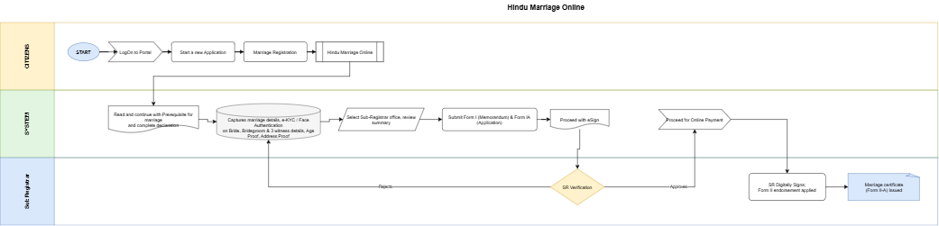

Figure: Hindu Marriage Online process
Flow (continuing from 7.i.b.A step 7 — Online-specific steps):
# | Step | Lane | Notes
7 | Capture marriage / e-KYC / Face Authentication/Face Authentication on Bride details / Bridegroom / 3 witness details | System / Citizen | Per Online diagram: e-KYC / Face Authentication applied on Bride details during capture (Bridegroom e-KYC / Face Authentication)
8 | Select Sub-Registrar office and review summary of updated information | System / Citizen | Jurisdiction routing
9 | Submit Form I (Memorandum) and Form IA (Application) | System / Citizen | Form I & Form IA generated for the selected office
10 | Proceed with eSign | System / Citizen | Citizen eSign on Form I and Form IA
11 | SR Verification (decision) | Sub Registrar | Approve or Reject
11a | Reject → return to Enter Marriage / Bride / Bridegroom / Witness details | Sub Registrar → System | Citizen corrects and resubmits; refusal reason recorded
12 | Proceed for Online Payment | System / Citizen | Payment occurs only after SR approval
13 | SR Digitally signs | Sub Registrar | DSC applied
14 | Form II endorsement applied; marriage certificate (Form II-A) generated | Sub Registrar / System | Form II endorsement (Rule 4(4)) then Form II-A available for download

Key characteristics: channel before combined prerequisite+declaration; e-KYC / Face Authentication on Bride details during capture; office selection + summary; Form I & Form IA + eSign; SR digital signature applies Form II endorsement and issues Form II-A certificate; no printout, no appointment, no DEO; single SR verification; payment only after SR approval; fully digital signature chain.

Offline (In Person)
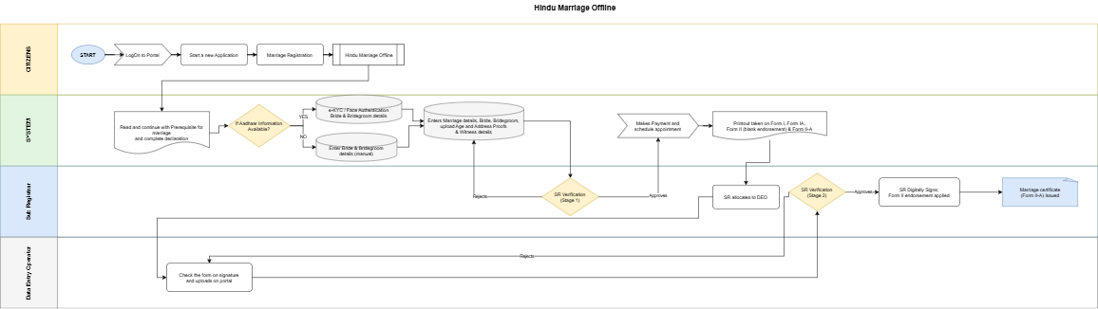

Figure: Hindu Marriage Offline process
Flow (continuing from 7.i.b.A step 7 — Offline-specific steps):
# | Step | Lane | Notes
7 | Whether Aadhaar information available? If Yes → e-KYC / Face Authentication on Bride & Bridegroom details; else Enter Bride & Bridegroom details (manual) | System / Citizen | Per Offline diagram (Aadhaar YES/NO branch); witness details captured with party particulars
8 | SR Verification — Stage 1 (decision) on captured application data | Sub Registrar | Approve or Reject
8a | Reject → return to Enter Marriage / Bride / Bridegroom / Witness details | Sub Registrar → System | Citizen corrects and resubmits
9 | Makes Payment and schedule appointment | System / Citizen | Payment and slot booking in one step, after Stage 1 approval
10 | Printout taken on Form I, Form IA, Form II (blank endorsement) and Form II-A | System / Citizen | Citizen prints the statutory forms per Karnataka Hindu Marriage forms
11 | SR allocates to DEO | Sub Registrar | Explicit allocation step per updated Offline diagram before DEO upload
12 | Parties and witnesses sign physically; citizen attends the SRO on the appointment date | Citizen (offline activity) | Not a system step; precondition for DEO upload
13 | Check the form on signature and uploads on portal | Data Entry Operator | DEO verifies signatures are present/complete, scans and uploads
14 | SR Verification — Stage 2 (decision) on the uploaded signed forms | Sub Registrar | Approve or Reject
14a | Reject → return to DEO check / upload step | Sub Registrar → DEO | Re-check or re-upload; does not go back to citizen data entry
15 | SR Digitally Signs | Sub Registrar | DSC applied
16 | Marriage certificate Issued | Sub Registrar / System | Form II-A issued

Key characteristics: channel before combined prerequisite+declaration; whether Aadhaar available — e-KYC / Face Authentication on Bride & Bridegroom or manual data entry (Aadhaar YES/NO branch); SR Verification Stage 1 on captured data before payment; payment + appointment bundled; printout of Form I, Form IA, Form II (blank endorsement) & Form II-A; SR allocates to DEO; DEO signature check and upload; SR Verification Stage 2 on uploaded signed forms (reject returns to DEO); SR DSC applies Form II endorsement then certificate.

Application Status Model
Channel-aware application statuses for Hindu Marriage Online and Offline:
Status | Description | Actor | Next states
Draft | Saved not submitted | Citizen | Channel selected
Channel selected | Online or Offline chosen (before prerequisites) | Citizen | Prerequisite & declaration completed
Prerequisite & declaration completed | Combined prerequisite + declaration acknowledged | Citizen | Details captured
Details captured | Marriage / bride / bridegroom / witness details saved (Online: e-KYC / Face Authentication on Bride details; Offline: e-KYC / Face Authentication on Bride & Bridegroom when Aadhaar available, else manual) | Citizen | Office selected (Online) / Pending SR verification Stage 1 (Offline)
Office selected & summary reviewed | SRO office chosen, summary confirmed | Citizen | Form I & Form IA submitted
Form I & Form IA submitted | Form I (Memorandum) and Form IA submitted | Citizen | eSign pending
eSign pending | Awaiting citizen eSign | Citizen | Pending SR verification
Pending SR verification | Awaiting SR scrutiny | SR | Approved for payment / Rejected — data
Rejected — data correction | Sent back to citizen data entry | SR | Details captured
Approved for payment | SR approved; fee payable | SR | Payment completed
Payment completed | Fee paid, receipt issued | System | Pending SR digital signature (Online) / Appointment scheduled (Offline)
Appointment scheduled | SRO visit slot booked | Citizen | Forms printed
Forms printed | Form printout taken | Citizen | Allocated to DEO
Allocated to DEO | SR has allocated the application to a DEO | SR | Awaiting signed-form upload
Awaiting signed-form upload | Physically signed forms pending at SRO | Citizen / DEO | Signed forms uploaded
Signed forms uploaded | DEO checked signatures and uploaded | DEO | Pending SR verification — Stage 2
Pending SR verification — Stage 2 | Awaiting SR scrutiny of signed forms | SR | Pending SR digital signature / Rejected — upload
Rejected — upload | Sent back to DEO for re-check / re-upload | SR | Signed forms uploaded
Pending SR digital signature | Awaiting DSC | SR | Registered
Registered | Serial / page / volume assigned, Form II endorsed | SR | Certificate issued
Certificate issued | Form II-A Generated / downloadable | System | Closed
Closed | No further action | System | —

Special Marriage Notice Generation (Intended Marriage / Other Forms)
Intended Marriage (Chapter II) and Other Forms (Chapter III) share a single notice-generation workflow. After Marriage Registration the citizen answers Whether Marriage already taken place or not?: No routes to Special Marriage (Intended Marriage Notice); Yes routes to Special Marriage (Other Forms Notice) and then Enter Marriage Details (date, place and form / rites of the already celebrated ceremony) before Prerequisite. Both paths then share Prerequisite; party capture (Online: mandatory e-KYC / Face Authentication; Offline: Aadhaar YES/NO branch or manual); Online or Offline publication; first payment; eSign / notice-board and the 30-day countdown.

Channel models
Notice generation supports Online and Offline (In Person) channels for both Intended Marriage and Other Forms. The selected notice channel drives publication mode (portal vs notice board) and office tasks. Service path (Intended Marriage vs Other Forms) is decided by Whether Marriage already taken place or not? immediately after Marriage Registration; Other Forms additionally captures marriage details before Prerequisite.
Service Type | Online Activities | Office Activities | Mode
Special Marriage Notice — Online (Intended Marriage / Other Forms) | e-KYC / Face Authentication bride & bridegroom, document upload (incl. photos), First Payment, portal notice, eSign | SR verification; System notice generation (no DEO / appointment) | Online notice
Special Marriage Notice — Offline (Intended Marriage / Other Forms) | Capture details (e-KYC / Face Authentication when Aadhaar available, else manual), document upload, First Payment, appointment | SR verification, notice generation, DEO photo/print/sign/scan/upload, paste on notice board | Offline notice

Process Diagram

Common intake steps
Identical in both notice diagrams (Citizens and System lanes). Intended Marriage and Other Forms share these steps through Prerequisite (step 7); the path decision and Other Forms Enter Marriage Details branch are in steps 5–6. Party capture continues per the Online (7.ii.b.B) or Offline (7.ii.b.C) notice diagram:
- START — citizen initiates the service.
- LogOn to Portal — authenticated citizen session.
- Start a new Application.
- Marriage Registration — citizen selects the marriage registration service.
- Whether Marriage already taken place or not? — No: Special Marriage (Intended Marriage Notice); Yes: Special Marriage (Other Forms Notice). Online vs Offline is the selected notice channel (separate diagrams 7.ii.b.B / 7.ii.b.C). Marriage Registration (certificate) is initiated later by selecting an approved notice (see 7.iii).
- If Other Forms (Yes): Enter Marriage Details — date, place and form / rites of the already celebrated ceremony (not required for Intended Marriage). Both paths then continue to Prerequisite.
- Read and continue with Prerequisite for marriage and complete declaration — single combined acknowledgement screen (eligibility, documents, channel implications and statutory declarations). SR rejection of the notice application returns here for correction and resubmission.

Online
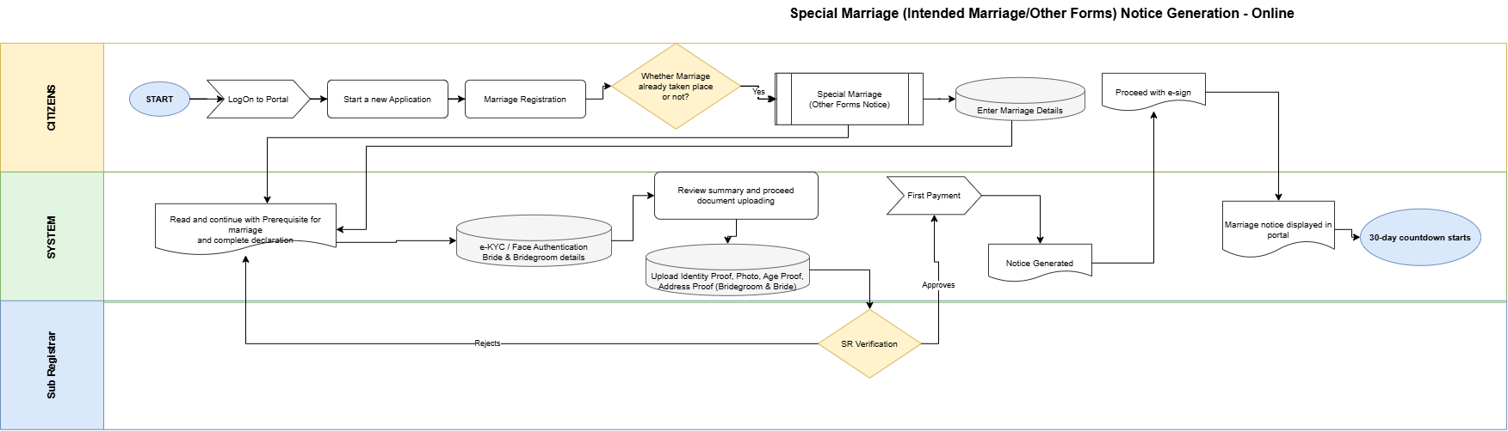
Figure: Special Marriage (Intended Marriage/Other Forms) Notice Generation — Online
Flow (continuing from 7.ii.b.A step 7 — Online notice-specific steps; shared by Intended Marriage and Other Forms):

# | Step | Lane | Notes
8 | e-KYC / Face Authentication on Bride & Bridegroom details | System / Citizen | Continues from 7.ii.b.A step 7; mandatory on Online notice diagram (no manual path)
9 | Review summary and proceed document uploading | System / Citizen | Summary of captured particulars
10 | Upload Identity Proof, Photo, Age Proof, Address Proof (Bridegroom & Bride) | Citizen | Mandatory supporting documents including individual photographs
11 | SR Verification (decision) | Sub Registrar | Approve or Reject
11a | Reject → return to Prerequisite & declaration | Sub Registrar → Citizen | Citizen corrects and resubmits (diagram returns to Prerequisite)
12 | First Payment | System / Citizen | Notice fee per Karnataka Special Marriage fee schedule
13 | Notice Generated | System | Statutory notice generated after first payment (no Online DEO / appointment)
14 | Proceed with e-sign | Citizen | Citizen eSign on the generated notice before portal publication
15 | Marriage notice displayed in portal | System | Sec. 6 publication (digital); follows e-sign per Online notice diagram
16 | 30-day countdown starts | System | Objection period per Sec. 7 / Sec. 16 from publication / portal display

Key characteristics (both paths): after the Whether Marriage already taken place or not? branch (Other Forms: Enter Marriage Details before Prerequisite), mandatory e-KYC / Face Authentication on Bride & Bridegroom; document upload including individual photos; SR verification before First Payment; System generates notice after payment; citizen e-sign on the generated notice; then Marriage notice displayed in portal; no Online appointment or DEO; 30-day countdown from publication (Sec. 7 / Sec. 16).

Offline (In Person)
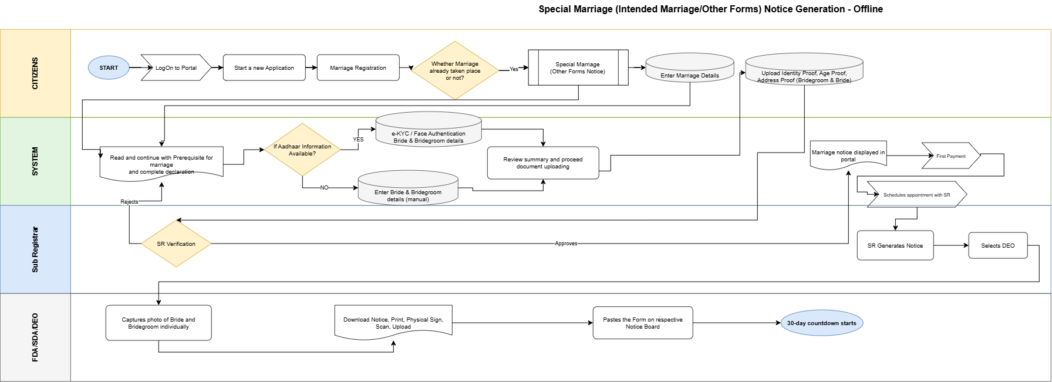
Figure: Special Marriage (Intended Marriage/Other Forms) Notice Generation — Offline
Flow (continuing from 7.ii.b.A step 7 — Offline notice-specific steps; shared by Intended Marriage and Other Forms):
# | Step | Lane | Notes
8 | If Aadhaar available → e-KYC / Face Authentication on Bride & Bridegroom details; else Enter Bride & Bridegroom details | System / Citizen | Continues from 7.ii.b.A step 7; per Offline notice diagram (Aadhaar YES/NO branch)
9 | Review summary and proceed document uploading | System / Citizen | Summary of captured particulars
10 | Upload Identity / Age / Address proofs (Bridegroom & Bride) | Citizen | Mandatory documents (individual photos captured later by DEO at office)
11 | SR Verification (decision) | Sub Registrar | Approve or Reject
11a | Reject → return to Prerequisite & declaration | Sub Registrar → Citizen | Citizen corrects and resubmits (diagram returns to Prerequisite)
12 | First Payment | System / Citizen | Notice fee
13 | Schedule appointment with SR | System / Citizen | After first payment
14 | SR Generates Notice | Sub Registrar | Statutory notice generation
15 | Selects DEO | Sub Registrar | Assign FDA/SDA/DEO
16 | Capture individual photos of Bride & Bridegroom | FDA / SDA / DEO | Office visit activity
17 | Download, Print, Sign, Scan and Upload notice | FDA / SDA / DEO | Physical notice processed into system
18 | Paste form on respective Notice Board | FDA / SDA / DEO | Sec. 6(2) conspicuous place publication; also drives portal display
19 | 30-day countdown starts | System | Objection period per Sec. 7 / Sec. 16

Key characteristics (both paths): after the Whether Marriage already taken place or not? branch (Other Forms: Enter Marriage Details before Prerequisite), Aadhaar YES (e-KYC / Face Authentication) / NO (manual) capture; SR verification → First Payment → appointment; SR generates notice & selects DEO; individual photo capture; physical notice-board paste (Sec. 6(2)) with portal display; 30-day countdown. SR rejection returns to Prerequisite & declaration.

Application Status Model
Application statuses for Special Marriage Notice Generation (Online / Offline; Intended Marriage and Other Forms):
Status | Description | Actor | Next states
Draft | Saved not submitted | Citizen | Channel selected
Channel selected | Online or Offline notice channel chosen (before prerequisites) | Citizen | Prerequisite & declaration completed
Prerequisite & declaration completed | Combined prerequisite + declaration acknowledged | Citizen | Details captured
Details captured | Online: bride / bridegroom particulars saved via mandatory e-KYC / Face Authentication. Offline: e-KYC / Face Authentication where Aadhaar available, else manual entry. Other Forms only: marriage details already saved at path selection (before Prerequisite) | Citizen | Notice application submitted
Notice application submitted | Special Marriage notice application submitted for SR scrutiny (documents and particulars complete; Online citizen eSign of the statutory notice occurs after Notice Generated — see Notice generated / Notice published) | Citizen | Pending SR verification — notice
Pending SR verification — notice | Awaiting Marriage Officer scrutiny of the notice application | SR | Notice approved / Rejected — notice data
Rejected — notice data | Returned to citizen for correction; flow returns to Prerequisite & declaration per notice diagrams | SR | Prerequisite & declaration completed
Notice approved | SR approved; first payment payable | SR | First payment completed
First payment completed | Notice fee paid, receipt issued | System | Notice generated
Notice generated | Statutory notice generated and entered in the Marriage Notice Book. Online: citizen eSign is performed on the generated notice before portal display | SR | Notice published (after Online e-sign where applicable)
Notice published | Published on portal after Online e-sign, or pasted on notice board after DEO upload (Offline); publication timestamp starts the countdown | System / DEO | Objection period running
Objection period running | 30-day statutory countdown in progress | System | Notice valid for registration / Objection filed
Objection filed | Objection recorded in the Marriage Notice Book | Public / SR | Under objection enquiry
Under objection enquiry | SR enquiry by summoning parties (decide within 30 days) | SR | Objected — closed / Notice valid for registration
Objected — closed | Objection upheld; notice removed from portal and tagged Objected | SR | Closed
Notice valid for registration | Path-specific: Intended Marriage — notice ≥ 30 and ≤ 90 days with no valid objection; Other Forms — notice ≥ 30 days with no valid objection | Citizen | Proceed to Marriage Registration (see 7.iii)
Notice expired | Validity window lapsed; fresh notice required | System | Closed
Closed | No further action | System | —

Special Marriage Marriage Registration (Intended Marriage / Other Forms)
Intended Marriage and Other Forms share a single registration workflow after notice publication. Path-specific branches: (1) timeline gate — Intended Marriage ≥ 30 and ≤ 90 days from publication; Other Forms ≥ 30 days (no ≤ 90 upper gate in the Other Forms registration diagram); (2) certificate schedule — Fourth Schedule after Chapter II solemnization vs Fifth Schedule after Chapter III registration.

Channel models
Marriage Registration continues from an approved / published notice after the statutory waiting period. Completion is Offline (In Person) at the Sub-Registrar office (solemnization or Chapter III registration, DEO certificate production and SR DSC). There is no separate fully-online registration channel.
Service Type | Online Activities | Office Activities | Mode
Special Marriage Marriage Registration (Intended Marriage / Other Forms) | Select approved notice (Intended: ≥30 & ≤90 days; Other Forms: ≥30 days), Second Payment, schedule visit, download certificate | Objection enquiry (if any), SR verification, DEO joint photo / witness / declaration / certificate, solemnization or Chapter III registration, SR DSC | Registration (In Person)

Process Diagram

Common intake steps
Portal and office steps are the same for Intended Marriage and Other Forms except the timeline gate and the certificate schedule. The process table in 7.iii.b.B is the authoritative step list; path-specific branches are in the Notes column.

Offline (In Person)
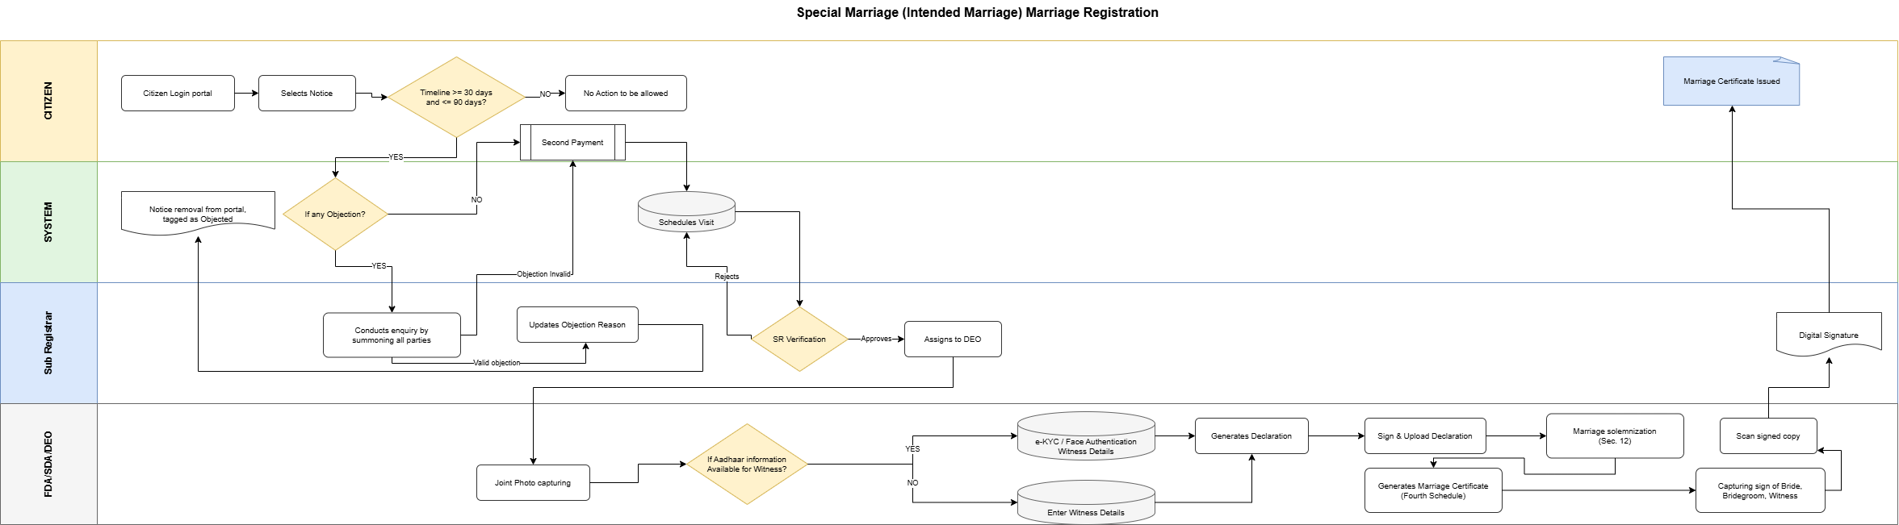

Figure: Special Marriage (Intended Marriage) Marriage Registration
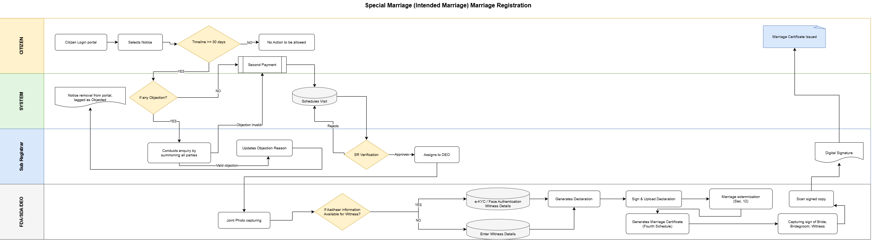

Figure: Special Marriage Other Forms Marriage Registration
Flow (after notice publication — registration / solemnization steps; shared by Intended Marriage and Other Forms):

# | Step | Lane | Notes
1 | Citizen Login portal | Citizen | Continue from published notice
2 | Select Notice | Citizen | Choose approved / published notice
3 | Validate timeline — Intended: ≥ 30 and ≤ 90 days (Sec. 7 / Sec. 14); Other Forms: ≥ 30 days (no ≤ 90 gate) | System | If NO → No Action allowed (path-specific gate)
4 | If any Objection? | System | Branch to SR enquiry when objection exists
4a | Conduct enquiry by summoning all parties | Sub Registrar | Sec. 8–9
4b | Valid objection → update reason; Notice removal from portal (Objected) | Sub Registrar / System | Process stops for solemnization
4c | Objection invalid → continue | Sub Registrar | Proceed to Second Payment
5 | Second Payment | System / Citizen | Registration / solemnization fee
6 | Schedule Visit | System / Citizen | Office visit for solemnization
7 | SR Verification (decision) | Sub Registrar | Approve or Reject
7a | Reject → return to Schedule Visit | Sub Registrar → System | Reschedule / correct
8 | Assigns to DEO | Sub Registrar | Certificate / declaration production
9 | Joint Photo capturing | FDA / SDA / DEO
10 | If Aadhaar available for Witness → e-KYC / Face Authentication Witness Details; else Enter Witness Details | FDA / SDA / DEO | Three witnesses (Sec. 11) — after joint photo
11 | Generates Declaration | FDA / SDA / DEO | Third Schedule declarations
12 | Sign & Upload Declaration | FDA / SDA / DEO | Signed declaration uploaded
13 | Marriage solemnization (Intended, Sec. 12) / registration (Other Forms, Chapter III Sec. 15–16) | Sub Registrar | Chapter II solemnization vs Chapter III registration
14 | Generate Marriage Certificate — Fourth Schedule (Intended) / Fifth Schedule (Other Forms) | FDA / SDA / DEO | Fourth Schedule Sec. 13 / Fifth Schedule Sec. 16
15 | Capture signs of Bride, Bridegroom, Witness | FDA / SDA / DEO
16 | Scan signed copy | FDA / SDA / DEO
17 | Digital Signature (DSC) | Sub Registrar
18 | Marriage Certificate Issued | Citizen / System | Download from portal

Key characteristics: notice selection with path-specific timeline gate (Intended ≥30 and ≤90; Other Forms ≥30); objection enquiry branch (valid objection removes notice); Second Payment; schedule visit; SR verification; DEO joint photo then witness capture (e-KYC / Face Authentication or manual), declaration generate/sign/upload, solemnization or Chapter III registration, certificate & signatures; SR DSC; certificate issuance (Fourth or Fifth Schedule).

Application Status Model
Application statuses for Special Marriage Marriage Registration (Intended Marriage / Other Forms):
Status | Description | Actor | Next states
Notice valid for registration | Entry point — Intended: notice ≥ 30 and ≤ 90 days with no valid objection; Other Forms: notice ≥ 30 days with no valid objection | Citizen | Second payment completed
Second payment completed | Registration / solemnization fee paid | System | Visit scheduled
Visit scheduled | Solemnization visit (Intended) or registration visit (Other Forms) booked | Citizen | Pending SR verification — visit
Pending SR verification — visit | SR verification before solemnization | SR | Solemnized / Rejected — visit
Rejected — visit | Returned to visit scheduling with reason | SR | Visit scheduled
Solemnized | Marriage solemnized (Chapter II) or conditions satisfied for registration (Chapter III) | SR | Allocated to DEO — certificate
Allocated to DEO — certificate | Joint photo, certificate generation and signature capture | DEO | Signed certificate uploaded
Signed certificate uploaded | Signed certificate uploaded for SR digital signature | DEO | Pending SR digital signature
Pending SR digital signature | Awaiting DSC | SR | Certificate issued
Certificate issued | Marriage certificate downloadable from portal | System | Closed
Closed | No further action | System | —

Marriage — Null and Void Endorsement (Court Order)
Back-office workflow triggered when a competent court passes an order declaring a registered marriage void (sec 11) or annulling a voidable marriage (Sec. 12, the Sub-Registrar records the court order and flags the existing registration as Null and Void. This workflow is initiated only on presentation of a certified court order copy — not from citizen self-service or automated eligibility checks.

Process steps
Offline (In Person) at the Sub-Registrar office — steps only (no process diagram):
# | Step | Lane | Notes
1 | Sub-Registrar receives certified copy of court order declaring the marriage void or annulled (nullity decree) | Sub Registrar | HMA 1955 Sec. 11–12; physical or scanned copy presented at SRO office
2 | Sub-Registrar searches and opens the registered marriage record in Kaveri | Sub Registrar | By registration number, party name or Form II-A certificate number
3 | Sub-Registrar verifies court order particulars against the register entry (court name, case number, order date, parties) | Sub Registrar | Hard stop if parties or registration number do not match
4 | Sub-Registrar uploads / scans the court order copy | Sub Registrar | Mandatory artefact; retained per records policy (Rule 10)
5 | Sub-Registrar records nullity type as declared in the court order — Void (Sec. 11) or Voidable / annulled (Sec. 12) | Sub Registrar | Selection driven by court order wording
6 | Sub-Registrar flags the marriage registration as Null and Void | Sub Registrar | Endorsement on register entry; supersedes prior Registered / Certificate Issued status
7 | System updates register entry and certificate status | System | Form II-A marked invalid; Hindu Marriages Register shows NULL AND VOID endorsement
8 | System prevents issuance of certified extracts without null/void notation | System | Any subsequent extract shall reflect the endorsement (Rule 8)
9 | Audit trail recorded | System | Officer, timestamp, court order reference, prior and new status

What is new in Kaveri 3.0
This section summarises material enhancements in Kaveri 3.0 compared with the legacy Kaveri 2.0 Marriage Registration module (6). Capability highlights are listed below; 7.v.a maps each As-Is pain point from 6.1 to the Kaveri 3.0 closure. Cross-references point to To-Be process in this BRD (7.i–7.iv) and to functional / non-functional requirements in FRS_and_NFRS_Marriage_v1.22.docx.
# | Capability | What is new in Kaveri 3.0
1 | Dual-channel services | Special Marriage Notice
2 | Identity verification | Face Authentication on Online paths
7 | Null and Void endorsement | SRO back-office workflow to record certified court order and flag registered Hindu marriage Null and Void (HMA 1955 Sec. 11–12)
9 | Data capture and address quality | Structured party/witness capture; MDM-driven address; place of marriage in summary and reports; cross-reference search for registered marriages
10 | Payments and notifications | Integrated fee payment with receipt (Form VI); resilient payment fallback; SMS and e-Mail notifications across application lifecycle
11 | Integrations | Kutumba portal, Civil Registration System, Labor Department
12 | UI/UX experience | Mobile-responsive bilingual UI (English + Kannada); guided step flow with Save/resume; summary review before submit and eSign

Rectified As-Is pain points
The following As-Is pain points from 6.1 (Kaveri 2.0 workshops, ServiceDesk tickets and department discussions) are closed in Kaveri 3.0. Cross-references point first to the To-Be process in this BRD (7.i–7.v), then to functional requirements, fallbacks or NFRs in FRS_and_NFRS_Marriage_v1.22.docx that implement the fix.
Sr.No | Pain Point (As-Is) | How rectified in Kaveri 3.0
1 | Not mobile-friendly | Mobile-responsive bilingual UI; guided step flow usable on phone browsers
2 | Incorrect address on certificate | Structured party address capture without erroneous sub-district on Form II-A
3 | Complex area/village selection | MDM-driven jurisdiction / area selection with simplified routing
4 | Restrictive document upload rules | Relaxed size/dimension rules with clear validation messages for supporting documents
5 | Missing Save action for Witness 3 | Witness capture supports Save for all three witnesses before submission
6 | Edit does not return to correct step | Edit from in-progress application resumes at the correct channel-aware status step
7 | Documents not visible during scrutiny | SRO scrutiny view shows all uploaded supporting documents with the application
8 | No edit flexibility before payment | Citizen may navigate back and edit captured data until sub-registrar approval for payment
9 | No processing priority order | FIFO / priority handling for officer queues
10 | Password-protected uploads not handled | Clear reject/retry for password-protected documents (FB-MRG-003)
11 | Limited notification channels | Lifecycle notifications via both SMS and e-Mail
12 | No operational dashboard visibility | MIS / dashboard for daily registrations, pendency and officer workload
13 | Wrong DEO allocation and no reassignment | SR allocates to DEO; officers can reassign without Service Desk
14 | Notice workflow state errors | Channel-aware notice / registration status model; post-period actions gated correctly
15 | Blank challan / verify-challan loop | Integrated payment with receipt and resilient payment fallback
16 | Stuck on summary page — cannot go to next step | Summary review then proceed / eSign with explicit next-step navigation
17 | DOB and party details not reflecting | Party particulars (including DOB) persist and display on summary, forms and certificate
18 | Place of marriage missing in summary/report | Place of marriage captured once and shown on summary, forms and MIS
19 | Cross-reference to registered marriage missing | Search / cross-reference to registered marriage records (post-registration)
20 | Signatures missing on digitally signed certificate | Bride, bridegroom and witness signatures rendered on DSC-signed certificate
21 | Notice number and notice date not displaying | Notice number and notice date shown after generation / publication

Acceptance and sign-off of BRD and related documents
Role | Name | Signature / Date | Comments
Product Owner
Domain Expert
AIGR Computers
Business Analyst

